What happens to your body when you feel anxious or stressed?

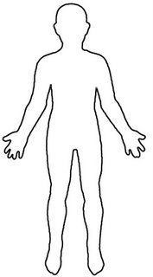
This resource has been created by Barnardo’s whilst they held the WESAIL contract 2018-2022 AND EDITED FOR USE BY Barnardo’s SENDIASS Bradford 2022.

