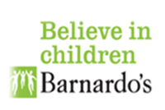
Information about
Bradford SENDIASS
for children and young people
SENDIASS | The letters in SENDIASS stand for Special Educational Needs and Disabilities Information, Advice and Support Service.
 | You can get help and information from SENDIASS if you have a special educational need or disability.
 | Special educational needs means that you need extra help to learn things.
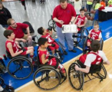 | A disability is a physical or a mental need that makes it hard to do things like walk, talk or see.
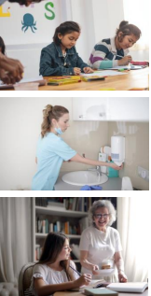 | SENDIASS can help you with lots of things, like:  - School  - College  - Health  - care
 | The advice we give is impartial. This means that it should be the right advice for you. It does not matter what other people think is the right advice.
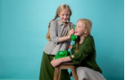 | You can contact SENDIASS, or someone can do it for you.
 | You can call us on 01274 513300
 | You can email us at bradfordSENDIASS@barnardos.org.uk
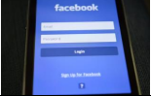 | The Facebook page is: https://www.facebook.com/BradfordSendiass/
 | The Instagram page is: https://www.instagram.com/bradfordsendiass/
 | The twitter page is: https://twitter.com/BradfordSENDIAS

