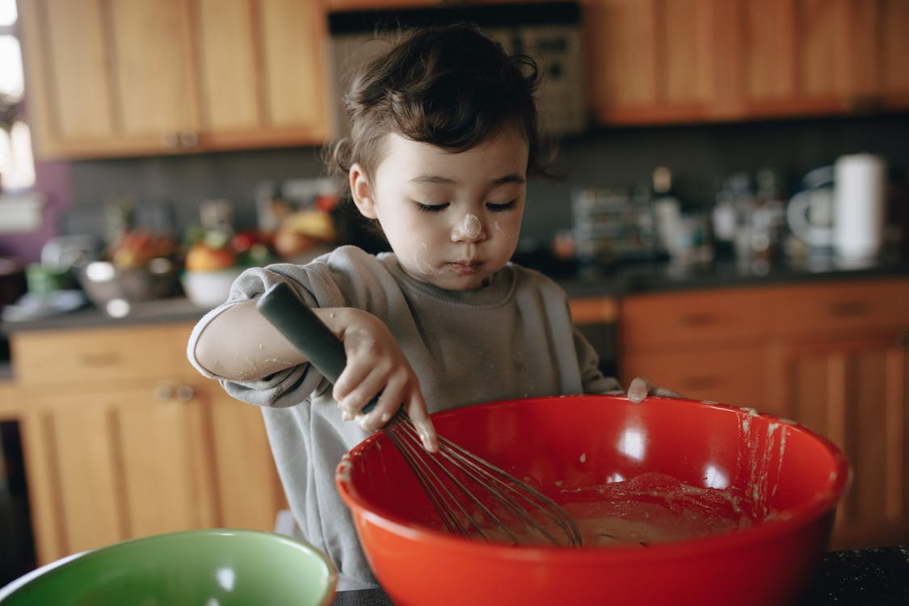
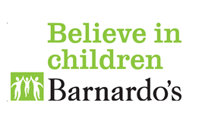
Making your own playdough is the best way to be sure it does not contain any chemicals in case your child has a little nibble or lick of it! It means you can make it to suit your child’s likes, dislikes and needs. It also saves money and is more hygienic as you can make as much as you need for throwing away more frequently.
There are many recipes available online that involve microwave cooking, pan cooking or even no cook. Some recipes include the use of cream of tartar which can help to maintain the elasticity of the playdough and then you can keep it for longer however it is not essential to use it.
Explore what your child/ren like by using different items to stimulate their senses. You can include or leave out items based on any allergies or sensory needs. Here a few ideas of what you might like to try:
Dry ingredients
*Cocoa powder *Custard powder *Dried herbs such as mint; lavender;basil
*Spices such as ginger; cinnamon; tumeric; nutmeg; paprika
Wet ingredients
*Food colouring *Food flavouring e.g. citrus; vanilla; mint
*Natural food colours & flavourings such as veg and fruit juices
Please note-some colours can stain hands and clothing but these will wash out with time. If concerned, we suggest wearing an apron and/or old tshirt
Decoration
Mix in glitter or sequins if you’re confident they won’t be eaten or nibble friendly items such as cake sprinkles; desicated coconut; herbs; fruit peel
*Please note -do not use glitter or any metal-based sequin in a mix prior to being placed in the microwave recipe*

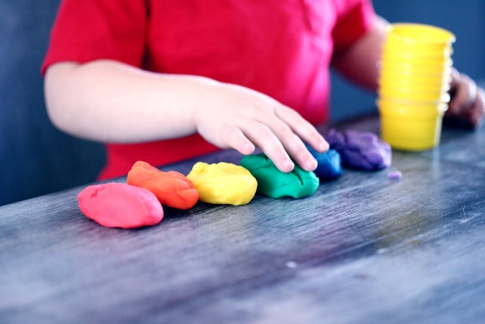
RECIPES

Gluten free playdough
- ½ cup/118 grams white rice flour
- ½ cup corn starch
- ¼ cup table salt
- 2 tablespoons (tbsp) cream of tartar
- 1 cup water
- 1 tbsp oil, coconut or canola
- 1-2 drops gel food colouring
- Whisk the dry ingredients together in the saucepan.
- Add the oil and food colouring to the water and stir.
- Pour the wet ingredients into the saucepan and whisk to combine.
- Over medium heat, stir constantly with a rubber spatula until all the liquid has absorbed and a ball of dough appears. About 5 minutes.
- Remove from heat and place dough on a piece of parchment paper to cool.
- When cool enough to handle, knead the dough until smooth.
- Store in an airtight container.
Microwave playdough
1 cup plain flour
1 tbsp. oil
1 cup water
½ cup salt
2 tbsp. cream of tartar
Food colouring
*Double the recipe for larger groups of children*
- Pour all dry ingredients, flour, salt and cream of tartar together into a microwave heat proof container, casserole dish or bowl.
- Add water and oil to dry ingredients. Add food colouring until desired colour is achieved.
- Mix together using a whisk to remove lumps and blend the ingredients well.
- Cover and place in the microwave for 2 minutes on high.
- Remove from microwave and stir with a wooden spoon.
- Place in the microwave for 1 min, remove and stir to combine. Cook for a further minute if the play dough is still runny. *Microwave times may vary*
- Then turn out onto a clean surface and knead into a smooth ball. Be careful the play dough will be very hot! Use a little bit of flour if the play dough is sticky.
- Allow the play dough to cool before playing with it.
- Store in a plastic zip lock bag or air-tight container.

Salt dough
Salt dough is a more permanent version of playdough in that anything you make can be slowly baked and then painted afterwards. There are also recipes that air dry rather than bake.
Salt dough is not harmful to eat in small amounts but is not recommended and would not taste nice so often children will not return to it after one lick!
How to make salt dough - BBC Good Food
Things to do with dough
The list is endless of what can be done with dough but here are a few ideas:
- Explore and play! The sensation alone can be fun and therapeutic
- Use in the way you would if cooking or baking -such as cookies;gingerbread people;cupcakes
- Create sculptures, figures and creatures
- Make birthday or reward badges out of saltdough
- Use items found on a sensory walk to make inprints in to play or saltdough
- Make “money” & items to “sell” in a role-play shop
- Create self portraits using a mirror to copy shapes, colours and forms

Edible paint
This can be used for painting onto food items such as biscuits, rice crackers or even toast. And of course - fingers!
You can also explore using natural colourings such as those listed previously
- 1 (14 ounce) can sweetened condensed milk
- Gel food colouring
- Clean paintbrushes (new is best or better yet food-safe)
- Divide the sweetened condensed milk into containers.
- Add a drop of food colouring and mix well.

Take one box
Many people joke about how a child is more interested in the box a gift came in than the actual present!
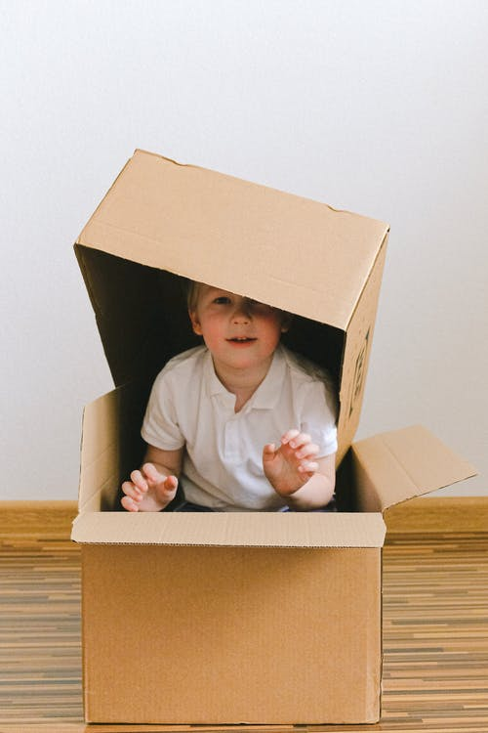
Is it a box or is it a…?
Let your imagination run wild and add other boxes, tubs and cartons.

Use the box to play in or alongside

- Pirate ship
- Supermarket
- Ice-cream van
- Delivery lorry
- House
- Hideout/den
- Post box for Santa’s letters
- Mobile library
- Robot
- Make believe creature
- Garage
- Train/bus station
Enhance play
- Peekaboo is an underestimated teaching aid that helps children learn to use eye tracking, anticipation, and language
- Use the words “Ready, steady, go” throughout play to aid the same learning
- Eye contact can be encouraged by waiting until your child looks at you before you say “go”. This can be used in many ways such as when releasing a car down a ramp; before opening a box; as posting a letter
Please see also “Role-play ideas” sheet

