Anxiety and stress:
evaluation questions

 | Yes 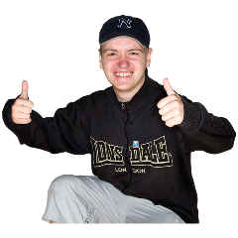 | Not sure  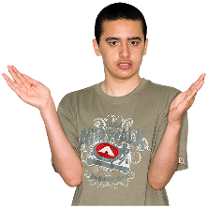 | No  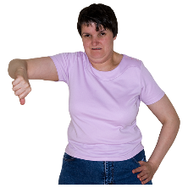
I know what anxiety and stress are.

I know what happens to my body if I feel like that.

I have a plan for how I could sort some of the things that make me feel anxious or stressed.

I have some ideas about how I can make myself feel calm again if I am anxious or stressed.

This resource has been created by Barnardo’s whilst they held the WESAIL contract 2018-2022 AND EDITED FOR USE BY Barnardo’s SENDIASS Bradford 2022.
This resource has been created by Barnardo’s whilst they held the WESAIL contract 2018-2022 AND EDITED FOR USE BY Barnardo’s SENDIASS Bradford 2022.

