How to guide your child in choices
As we have discussed, raising your child’s resilience and promoting independence can impact positively on their wellbeing and development.
However, it can be challenging at times to provide your child with choices as what they want and what is available, appropriate or safe can be different.
Too much choice
This is when you ask an open question such as “What do you want to drink?” or “Where shall we go today?”. These questions can be appropriate at times, but we would suggest considering if you can say yes to any request made. If the answer is no -consider guided choice
Not enough choice
Your child may feel like they do not have the independence and even though they may not yet be at a stage to understand this concept, it can result in them showing frustration, anger or unwanted behaviours.
A couple of examples would be providing your child with carrot batons for a snack; water to drink or telling your child which pair of socks to wear

Below are examples of how guided choice may look

Eating
- Offering child carrot batons or apple slices for a snack
- Asking child if wants to have red cup or blue cup for a drink
- Offering child milk or water in the cup
Road safety
- Asking child if they want to hold your hand or Dad/Mum/Grandma/Sisters hand -whomever may be there also
- Asking if is going to hold the pushchair or your hand
- Asking if they want to press the button or you press it for crossing
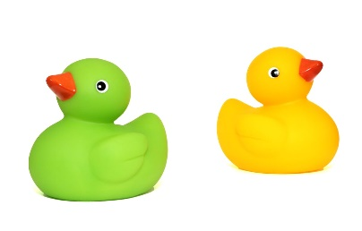
Bath time
- Offering child duck or cups to play with in the bath
- Do you want your bath before or after tea?
- To offer a choice of which towel/sponge/flannel/bubbles are used
Screen time
- Asking which coloured sand timer they wish to use
- Offering whether they use a tablet or a mobile for the allotted screen time
- Shall I turn off the tv or are you turning it off?
Outings
- Shall we go to see Grandma or to the farm today?
- Show teddy or dolly -child decides which to take
- Offer where to start with putting sun cream on -leg, arm, hand etc
Clothing
- Offer a choice of coloured items of clothing
- Are you using your umbrella or your hood?
- Are we putting your socks or vest on first?
Toileting/care routines
- Shall I count, or are you? (For length of time washing hands)
- Offering when to change nappy i.e. before/after lunch
- Who flushes the toilet
Bedtime
- Choice of which story
- Offer choice of which light they want on
- Choice of which bedwear to use
Reasonable adjustments -using photos, images, PECs or Makaton; using objects of reference; gesturing *See PowerPoint content for more detail*
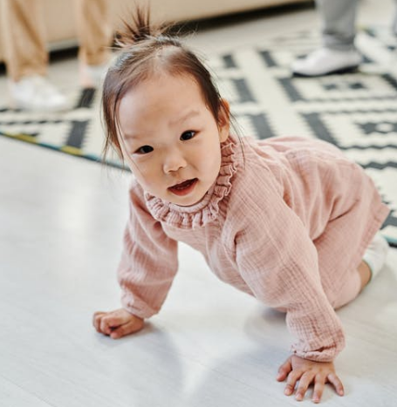
Unwanted behaviour versus inappropriate behaviour
We refer to unwanted rather than inappropriate behaviour with children as often how they react is age and stage appropriate but is unwanted for any given situation. For example -a toddler throwing themselves on the floor in the supermarket. This is unwanted but is very age and stage appropriate

www.henry.org.uk “…supporting the whole family to make positive lifestyle changes, creating healthier and happier home environments, and building healthier communities”

