
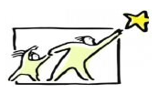
My goals!

Goal | When do I want to do this? | My reward for when I’ve done it!

