Confidence and self-esteem session:
evaluation questions

 | Yes 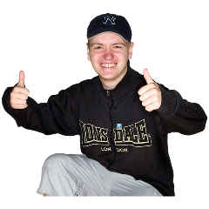 | Not sure  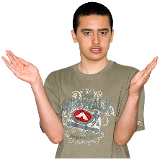 | No  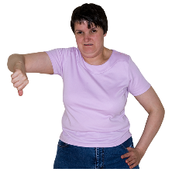
I know what confidence is

I have learnt some tips on how to be more confident

I am going to have a go at achieving my goals

I feel a little bit more confident than I did earlier

I have some ideas about what to do if my confidence is knocked




