Using PowerPoint | This is an Easy Read leaflet  It tells you about PowerPoint
PowerPoint is a computer programme that makes “presentations”

A “presentation” is used to give information

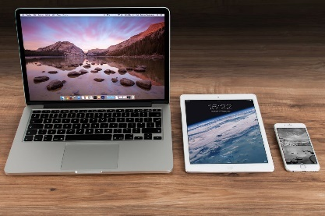 | You can see the information using different devices
 | It is best to look at it as a “slideshow”
 | To start you click on the button at the top named “Slide Show”
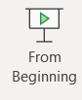 | Then click on the button at the top that says “From Beginning”
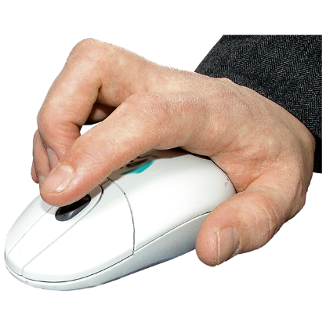 | To go through each page:  Click the mouse
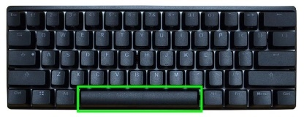 | Or use the space bar on your laptop or tablet
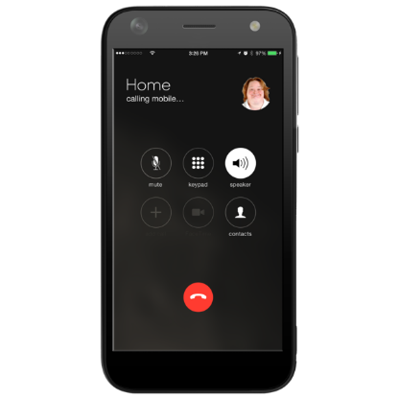 | On a mobile phone, use your finger
 | We also use “hyperlinks”
Blue | A “hyperlink” opens up a website when you click on it  The words are in blue
 | Open them using the mouse, space bar or your finger
 | You can get more help
These websites might help

PowerPoint help & learning - Microsoft Support

Accessibility support for PowerPoint - Office Support (microsoft.com)

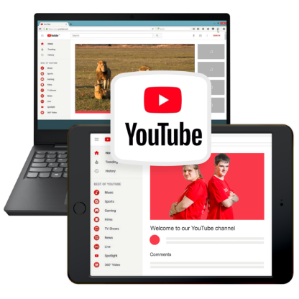 | There are videos online that might help
 | If you have questions, our staff can help
 | You can contact us to ask for support
You can email us
wesail@barnardos.org.uk

