****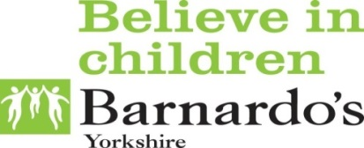

**What is advocacy?**

Advocates are people who help you to work out what you want to say and how to say it. They will make sure you are listened to and involved in decisions.

**CAPS**

**Children’s Advocacy and Participation Service**

Advocates from CAPS can help… If you are a Child in care or Leaving care, if you have Child protection meetings, Advocates can help if you have an Education and Health plan and if you have SEND or are working with the Youth offending team. We work for you to help you share your Views, wishes and feelings with adults who make decisions for you.

**CAPS**

**Independent Visitors Service**

**What is an Independent Visitor?**

An Independent Visitor is a trained volunteer who can spend quality time with a looked after child or young person. Independent visitors are for young people that only really get to talk to professionals.

Independent Visitors are people that will listen to you and help you gain more confidence, they are someone just for you, someone you can do fun activities with, like go to the Cinema, go out for walks and visits to museums. Independent Visitors can help you to share your views, wishes and feelings too, just like Advocate can.

If you would like to know more about us or if you think you would like support you can get in touch on:

Phone: 01977 552 493|Free phone: 0800 0121 552

Facebook: Wakefield CAPS

E-mail: wakefieldcaps@barnardos.org.uk



