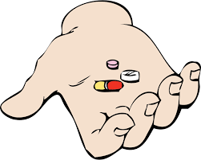

**Who is helping you today?**

**Bradford SENDIASS**

**What does this mean to me?**

**Words or information you don’t understand?** Write them down and ask ☺

**Why do I need this?**

**Support during the appointment**

**Medication Information;**

**Treatment Information;**

**What next?**

I will …

My parent/carer will …

My health worker will …

My next appointment …

**What is new or what has changed from my last appointment?**



**Who can I talk to after this appointment, if I have further questions?**