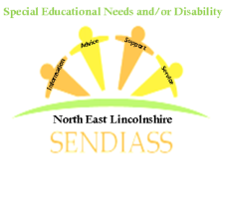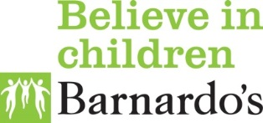

**North East SENDIASS Advocacy Offer**

We use the National IAS’ definition of ‘advocacy’ which is:

‘Advocacy means getting support from another person to help you express your views and wishes and help you understand and exercise your rights.

A SENDIASS Project worker will:

* listen to your views and concerns
* help you explore your options and rights (without pressuring you)
* provide information to help you make informed decisions
* help you contact relevant people, or contact them on your behalf
* accompany you and support you in meetings or appointments.

A SENDIASS Project worker will not:

* give you their personal opinion
* solve problems and make decisions for you
* make judgements about you.

The support of a SENDIASS Project worker, acting as an advocate, is often particularly useful in meetings when you might not feel confident in expressing yourself. They can:

* support you to ask all the questions you want to ask
* make sure all the points you want covered are included in the meeting
* explain your options to you without giving their opinion
* help keep you safe during the meeting – for example, if you find the meeting upsetting, your advocate can ask for a break until you feel able to continue.

North East SENDIASS do not fulfil the role of statutory advocates - nor do they provide legal advocacy as provided by a lawyer.

Different types of advocates include:

* **Independent Mental Health Advocates (IMHAs)**. These are specially trained advocates who can support certain patients under the [Mental Health Act 1983](https://www.mind.org.uk/information-support/legal-rights/mental-health-act-1983/). The law regarding IMHAs is different in England and Wales.
* **Independent Mental Capacity Advocates (IMCAs)**. These are specially trained advocates who can support certain people under the [Mental Capacity Act 2005](https://www.mind.org.uk/information-support/legal-rights/mental-capacity-act-2005/). For more information on whether you're entitled to an IMCA, and how to access one, follow this link [IMCAs](https://www.mind.org.uk/information-support/guides-to-support-and-services/advocacy/imcas/).
* **Social care advocates**. These can support certain people under the Care Act 2014 (in England) and the Social Services and Wellbeing (Wales) Act (in Wales). For more information on whether you're entitled to a social care advocate, follow this link [social care advocates](https://www.mind.org.uk/information-support/guides-to-support-and-services/advocacy/social-care-advocates/).

For more info about different types of advocacy services visit:

Mind: [https://www.mind.org.uk/information-support/guides-to-support-and-services/advocacy/legal-rights-to-advocacy/#](https://www.mind.org.uk/information-support/guides-to-support-and-services/advocacy/legal-rights-to-advocacy/)

Coram Voice: https://coramvoice.org.uk/get-help/alwaysheard/

[The Advocacy Charter Easy Read](https://www.ndti.org.uk/uploads/files/The-Advocacy-Charter-Easy-Read.pdf)

For more information about local advocacy services in North East Lincolnshire:

<https://www.cloverleaf-advocacy.co.uk/offices/north-east-lincolnshire>

[Voices Together](https://www.cloverleaf-advocacy.co.uk/sites/default/files/content_uploads/Voices%20Together%20leaflet%20correct_0.pdf) advocacy provides:

* Appropriate adult service for people with a learning disability
* General advocacy for people with a learning disability
* [Self-advocacy groups](https://www.cloverleaf-advocacy.co.uk/node/176)