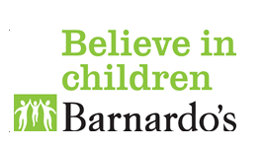
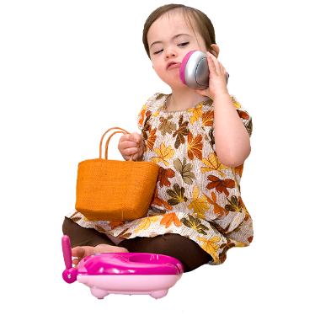
Role Play Ideas

Different stages of role play
At the early stages young children will copy what they see, hear and feel in their role play.
To help at this stage you can:
- Use ‘Running Commentary’ (see below)
- Take notice of what they enjoy looking at, listening to and touching.

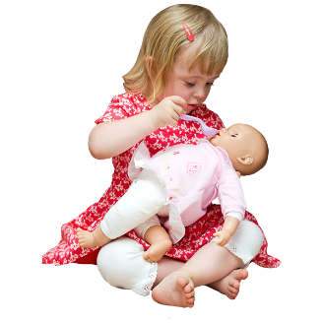
When they develop they will act out stories that they are familiar with, such as cooking tea, going to the shops or putting a baby to bed.
To help at this stage you can:
- Provide real items
- Tell or show them what you do in every day tasks
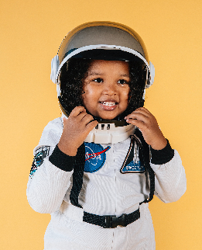
Later they may want to act out things they do not have experience of. For example, a child who is interested in spaceships may pretend to go into space and meet some aliens.
To help at this stage you can:
- Read, watch and find out more about their interest
- Use open-ended items (see below)

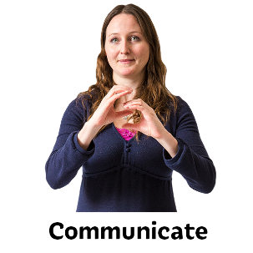
Running Commentary
This is where you talk about what your child is doing. This helps to develop their lanaguage and understanding.
Examples:
Ryan is moving a toy car along the table and then pushes it off the side. His parent says “Brum, brum, along it goes, across the table and whoosh! It flies off the edge!”
Nathan is flying his spoon around in the air. His parent uses his communication symbols to show a helicopter or aeroplane.
Zarella puts a toy thermometer in the ear of her cuddly toy. Her parent says “Now you’re checking the temperature of Teddy, the thermometer is in his ear… beep beep beep!”
Hervé crawls around the floor and uses his hand as a paw. He picks up a ball and takes it to his parent who throw it for him to ‘fetch’. His parent makes the signs for dog, ball, throw and fetch using makaton.
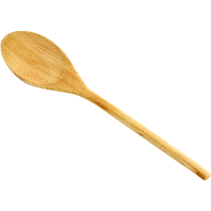
Open-ended resources
Open-ended resources are items that can be used in lots of different ways.
Here is a list of open-ended items with an idea of how to use them. It is not exhaustive!
- Cardboard box – could be a bed, a spaceship, a house
- Bowls, spoons – could be a drum kit, spoon could be a microphone
- Blankets – could be a den, a picnic blanket, a superhero cape
- Table and chairs – could be a boat, a train station
- Balls – could be planets or monsters
- Bricks – could be used as treasure, as role play food

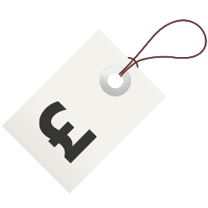
Ideas for using cheap or free items
Often the best things we can use for role play are free! You can always turn them into something else by drawing or painting them too.
- Used wrapping paper and gift bags – could be used to create party bags and wrapped ‘presents’
- Kitchen roll tubes / cardboard packaging – use these to make puppets, hats or telescopes
- Envelopes – use to make hand puppets
- Egg boxes – use these to make tresure chests, take away food boxes
- Old clothes – use to make doctors uniform, superhero cape, scientist’s lab coat
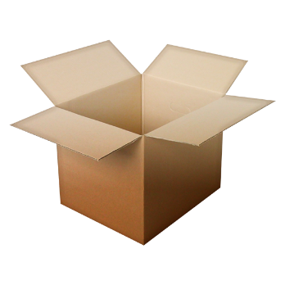
Box Fun!
Create a small role play box using an old container or cardboard box. Put in items that all go with each other. Let your child open and explore the box, making sure you name what everything is or use visuals. Use these items to tell stories.
Example:
Lucas loves superheros. In a small cardboard box his parent puts in a cape, mask, magnifying glass and some superhero comic books. Lucas holds the cape up to show his parent that he wants help to put it on. He then ‘flies’ around the living room. The next week his parent adds a toy phone to the box after they read a comic where the superhero is on the phone.

See also: Sensory Play Ideas Handout

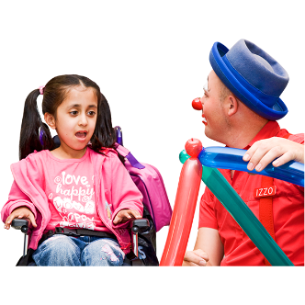
More Role Play Examples
Aysha is deaf and uses some makaton. Her parent notice she smiles and gestures a lot when visiting a local café. Her parent helps Aysha to choose plastic cutlery and crockery at home. They set up a café on a small table and use a teatowel as a table cloth. Her parent uses makaton signs for different food and drink. Aysha begins to copy some new signs as she enjoys the café role play.

Brie loves the circus. Her parent gets some balloons and some child-safe face paint crayons. Brie enjoys using the crayons on her parent, drawing a red nose. They use and old hat and a stick for a magic show. Brie bangs the stick on the hat, pulling out a toy rabbit.

