Ways to Promote Resilience in the Early Years
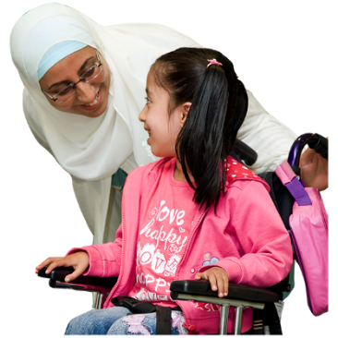
- Build good relationships

You can do this by:
- Spending time with your child
- Praising them when they have done well
- Helping them when they make a mistake and saying it’s ok
- Being a role model (acting how you want them to be)

- Support Self-Regulation

You can do this by:
- Talking about feelings
- Helping your child to identify their feelings
- Saying it is ok and normal to sometimes feed sad or angry
- Encourage your child to have things they can do when they feel sad, angry, or lonely e.g. cuddle a favourite toy
- Acknowledge how they feel by saying “I can see you are upset”

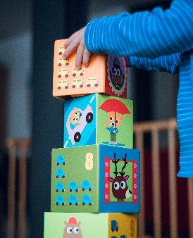
- Support them with mistakes

You can do this by:
- Letting your child make mistakes! We learn and build resilience by doing this
- Allowing your child time to solve problems or attempt tasks by themselves
- Break up a difficult task into smaller parts to help them achieve

- Help Them Through Changes

You can do this by:
- Talk / use communication visuals to talk about how they feel
- Use social stories
- Use teddies or role play to act out these situations

- Use Positive Language

You can do this by:
- Praising what they have done or tried to do
- When things do not go right first time saying “that’s ok, we can try again”

